Autumn 1 | Autumn 2 | Spring 1 | Spring 2 | Summer 1 | Summer 2
Year R | Year R | Year R | Year R | Year R | Year R
Literacy/Communication and Language:  The Kissing Hand by Audrey Penn  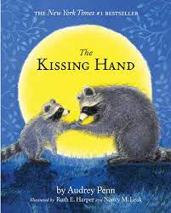  Engage in extended conversation about stories, learning new vocabulary.  Literacy:  We’re all Wonders  R.J.Palacio  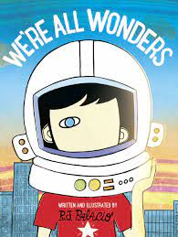  Use a wider range of vocabulary.  Expressing a point of view and to debate when they agree or disagree.  Literacy/ Communication and Language  The Colour Monster Goes to School.  Anna Llenas  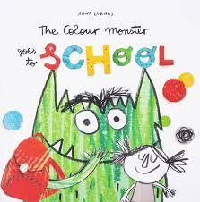  Engage in extended conversations about stories, learning new vocabulary.  Listen to and talk about stories to build familiarity and understanding.  Reading:  Dipal’s Diwali  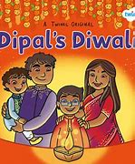  -Know some similarities and differences between different religious and cultural communities in this country, drawing on their experiences and what has been read in class. | Literacy: Supertato collection by Sue Hendra Purpose: Entertain.  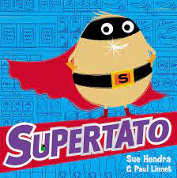  Understand five key concepts about print.  -Print has meaning  -Print can have different purposes  -We read English from left to right and top to bottom.  -The names of the different parts of a book  -Page sequencing.  Engage in story time  Use new vocabulary in new contexts  Spot rhymes/ alliteration  Writing:  Describing characters- labelling. Writing some letters accurately, spell words by identifying the sounds in them.  Literacy/ Communication and Language  Winnie the Witch  Valerie Thomas  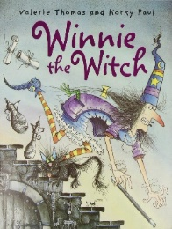  -Spot and suggest rhymes  -Listen attentively and respond to what they hear with relevant questions, comments and actions when being read to and during whole class discussions and small group interactions.  -Recognise words with the same initial sound  -Spell words by identifying the sounds an then writing the sounds with letters.  Literacy: The Nativity 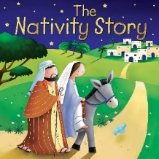  Retell through Nativity play. | Literacy/ Communication and Language:  Gigantosaurus by Jonny Duddle  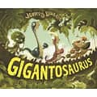  -Participate in small group, class and  one-to-one discussions.  -Using recently introduced vocabulary- in particular onomatopes  Literacy Writing:  Purpose: Inform  Flip Flap Dinosaur Axel Scheffler  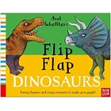  Use and understand recently introduced vocabulary during discussions about stories, nonfiction, rhymes and poems and during role play  -Spell words by identifying sounds in them and representing the sounds with a letter or letters.  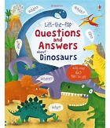  Reading:  Non-fiction  Questions and answers about Dinosaurs  Make comments about what they have heard and ask questions to clarify their understanding.  -Know some similarities and differences between things in the past and now, drawing on their experiences and what has been read in class  Literacy-Reading  I love Chinese New Year  Eva Wong Nava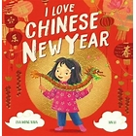  -Using Newley introduced language.  -UW talking about traditions and different celebrations.  -Know some similarities and differences between different religious and cultural communities in this country, drawing on their experiences and what has been read in class.  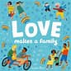  Love Makes a Family  Sophie Beer  -Learn new vocabulary and use it throughout the day.  (/UW links)  -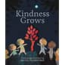  Literacy: reading-Poetry  Kindness Grows  Britta Teckentrup  -Develop social phrases  -Use talk to help work out problems and organise thinking. | Reading/Writing:  Purpose: Inform  Someone Swallowed Stanley  Sarah Roberts  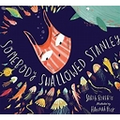  Greta Thunberg  Maria Sanchez Vegara  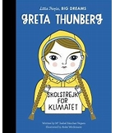  David Attenborough  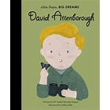  Greta and the Giants  Zoe Tucker  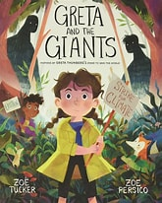  -Write simple phrases and sentences that can be read by others.  -UW link- protecting the environment- posters.  Writing:  Purpose: Entertain  Jack and the Beanstalk  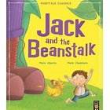  Retelling a traditional story using actions. Retell the story, once they have developed a deep familiarity with the text, some as exact repetition and some in their own words.  - Spell words by identifying the sounds and then writing the sound with letter/s.  -Write short sentences with words with known letter-sound correspondences using Capital letter and full stops.  -Use and understand recently introduced vocabulary during discussions about stories during roleplay.  -Express their ideas and feelings about their experiences using full sentences, including use of past, present and future tenses and making use of conjunctions.  Reading: The Easter Story/ Rameena’s Ramandan  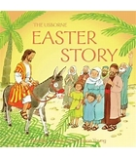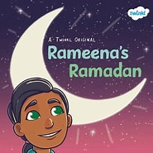  -Join in with group discussions.  -UW links- different family traditions. | Reading/Writing:  Purpose: To Entertain  The Pirate Cruncher and The Pirates next door  Jonny Duddle  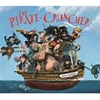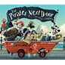  -Anticipate where key events in stories.  -Write simple phrases and sentences that can be read by others.  - Applying phonic reading/writing knowledge to write sentences- letters, stories, posters.  Reading-The Tree Keepers  Gemma Koomen  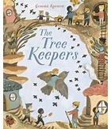  -Write simple phrases and sentences that can be read by others.  -Demonstrate understanding of what has been read to them by retelling stories and narratives using their own words and recently introduced vocabulary  Reading/Writing- Bob Baby/ The king of Tiny Things.  Jeanne Willis  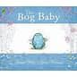  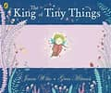  The Keeper of Wild Words  Brooke Smith  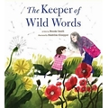  Express their ideas and feelings about their experiences using full sentences, including use of past, present and future tenses and making use of conjunctions.  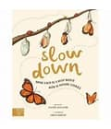  Literacy: Reading  Slow Down  Rachel Williams  - Describe their immediate environment using knowledge from observation, discussion, stories, non-fiction texts and maps.  - Know some similarities and differences between the natural world around them and contrasting environments, drawing on their experiences and what has been read in class. | Reading/Writing:  Purpose: To Entertain  Lots-The Diversity of Life on Earth  Nicola Davies  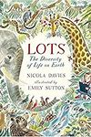  Handa’s Surprise  Eileen Browne  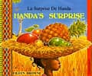  -Explain some similarities and differences between life in this country and life in other countries, drawing on knowledge from stories, non-fiction texts and (when appropriate) maps.  -Write simple phrases and sentences that can be read by others.  Literacy: Reading/Writing  Coming to England  Floella Benjamin  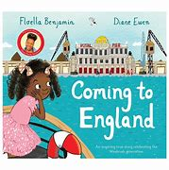  -Explain some similarities and differences between life in this country and life in other countries, drawing on knowledge from stories, non-fiction texts and (when appropriate) maps.

