

FAO : Parent and Carers | Sefton Council  Bootle Town Hall  Trinity Road  Bootle  Merseyside L20 7AE  19th May 2020

Dear Parents and Carers,

We would like to take this opportunity to set out the Councils position on the wider opening of Schools. We are aware of the significant differences in opinion on these matters nationally, and indeed locally, and believe there is no perfect solution.

Since 23rd March schools have remained open only to children of key workers and vulnerable children. Following the Prime Minister’s announcement on Sunday evening, schools will potentially open for children in Nursery, Reception, Year 1 and Year 6 as well from 1st June.

Secondary schools, sixth forms, and further education colleges will begin some face to face support with Year 10 and Year 12 pupils, however they will not be returning to full time education at the present time.

We appreciate that many of you remain concerned about the safety of your children and families if your children return to school. The latest scientific advice to the Government is that:

- severity of disease in children – there is high scientific confidence that children of all ages have less severe symptoms than adults if they contract coronavirus
- the age of children – there is moderately high scientific confidence that younger children are less likely to become unwell if infected with coronavirus
- numbers of children going back – which needs to be limited initially then increased gradually as the science permits
- systems to reduce the size of the groups coming into contact with each other – such as smaller class sizes spread out across settings

https://www.gov.uk/government/publications/actions-for-educational-and-childcare-settings-to-prepare-for-wider-opening-from-1-june-2020/

The Department for Education has provided advice for school leaders to support them with the next steps on the reopening of their schools which may start from 1st June, however as a council we are suggesting this from 15th June. The advice includes:

- Carrying out a risk assessment before opening to more children - the assessment will directly address risks associated with coronavirus so that sensible measures can be put in place to minimise those risks for children and staff.
- Making sure that children and young people do not attend if they or a member of their household has symptoms of Coronavirus.
- Promoting regular hand washing for 20 seconds and ensuring good respiratory hygiene by promoting the ‘Catch it, Bin it, Kill it’ approach.
- Cleaning more frequently to get rid of the virus on frequently touched surfaces, such as door handles, handrails, table tops, play equipment and toys.
- Minimising contact through smaller classes or group sizes and altering the environment as much as possible, such as changing the layout of classrooms.
- Reducing mixing between groups through timetable changes, such as staggered break and lunch times and by introducing staggered drop-off and collection times at different times.

https://www.gov.uk/government/publications/coronavirus-covid-19-implementing-protective-measures-in-education-and-childcare-settings

The Government is encouraging children in the eligible year groups to attend, unless they are self-isolating or there are other reasons for absence (such as shielding due to health conditions). However siblings in different year groups, unless they are children of key workers or vulnerable children will not be able to attend school yet. Although the government would like to see all eligible children return to school it is voluntary and as such no parent will be fined if their children do not attend.
The Government has produced further information for parents and carers. This information provides answers to a number of key questions. You can find the detailed answers to these questions by following the link: https://www.gov.uk/government/publications/closure-of-educational-settings-information-for-parents-and-carers/reopening-schools-and-other-educational-settings-from-1-june

Currently school leaders, including Governing Bodies are working through the government guidance that has been published during this week to consider best how to reopen their schools safely from the 1st June. Schools will only be able to open when they are satisfied that the necessary risk assessments have taken place. Robust plans will be put in place to ensure the health and safety of pupils and staff which will include adapting classroom space and resources for the different groups of pupils.

Please do be aware that every school is unique, has different circumstances and will be responding to them and the needs of their community in a variety of ways. Not every school will be able to have all the identified children back and not all will be able to do this on 1st June, which is why Sefton Council is recommending we aim for the 15th June. Sefton Council will continue to review the situation over the coming weeks.

We would like to take this opportunity to thank all our staff in schools and within the council who have worked tirelessly over the last few months to support so many of our families, whether they are in school or at home.

We appreciate that this has been a difficult time for parents and carers as well especially trying to home school your children. Our schools will continue to support you and provide a variety of work and activities for your children while they remain at home.

Your school leadership will ensure that you are kept fully informed of their approaches to the reopening of their school. The priority of the Council and school leaders is the safety of the children and the staff.

Yours faithfully

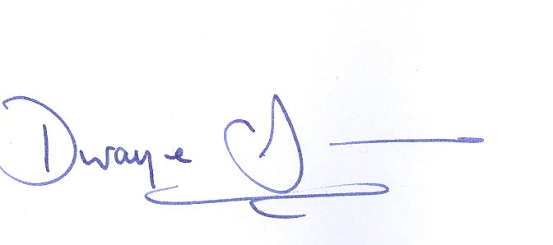  Dwayne Johnson  Chief Executive | Vicky Buchanan  Director of Children’s Social Care and Education

